**IUBAT - International University of Business Agriculture and Technology**

**Project Report**

**Title:** Mental Health Tracker

**Course Name** – Database Management System Lab

**Course Code** – CSC 434

**Submitted To,**

**Jubair Ahmed Nabin**

**Lecturer**

Department of Computer Science and Engineering

**IUBAT**

**Submitted By,**

Rifat Bin Alam

**ID:** 23103250

**Program:** BCSE

**Section:** I

**Semester:** Fall 2024

**Submission Date: 07-01-25**

**Mental Health Tracker**

**1. Introduction**

The **Mental Health Tracker** is designed to support the tracking and management of users mental health information. Such as mood, stress levels, and sleep times of a user. The main objective of this project is to design a database that ensures data integrity, supports efficient querying and is capable of handling large amount of user generated data. A key focus of this project is the database design, which will be central to managing users, the logs of a user and admin functionalities. It ensures smooth system performance and the usability.

**Importance of Database Design**

In the context of this **Mental Health Trakcer**, the database design is essential for organizing and storing users mental health data efficiently. It ensures that:

* User information and logs are easily accessed and edited.
* There is data consistency and accuracy in here.
* The system can scale even if more users are added.
* Reports can be generated based on users data. Example: Reporter can generate reports by gathering information of the mental health logs of a user.

A well-designed database reduces redundancy, ensures data integrity and optimizes performance. It is essential for any management system, especially this project which is dealing with sensitive mental health data.

**2. Project Overview**

This **Mental Health Tracker** aims to provide all users registered in this system with a tool to track their mental health over time. Users will be able to log various mental health parameters- such as mood, stress level and sleep hours. Admins will have access to the database for checking user registrations and adding resources related to mental health.

**Role of the Database**

The database is integral to the system’s functionality. It will:

* Store user information such as name, email, age, and gender.
* Store mental health logs containing mood, stress levels, sleep hours etc.
* Allow user to edit their data.
* Allow admins to add resources (videos, articles, picture links) related to mental health.
* Manage user goals (for example- set sleep or stress reduction goals) and track their progress.

**3. Requirements Analysis**

The **Mental Health Tracker** fulfilled the following requirements:

* **User Registration and Login**: Users can register, sign in and manage their profiles.
* **Mental Health Logs**: Users should be able to see and add their mood, stress level and sleep hours. They can also edit their health logs.
* **Goal Setting**: Users should be able to set goals as description for their mental health.Such as reducing stress or improving sleep.
* **Admin Functions**: Admins should have the ability to search users by their name and add/delete resources.
* **Resource Management**: Admins can add videos or pictures URLs to educate users about mental health.

**Key Entities, Attributes, and Relationships:**

* **Users**:
  + Attributes: user_id, name, email, password, age, gender.
  + Relationships: Users have many logs and goals.
* **Mental Health Logs**:
  + Attributes: log_id, user_id, date, mood, stress_level, sleep_hours.
  + Relationships: Each log is associated with one user.
* **Resources**:
  + Attributes: resource_id, title, category, link.
  + Relationships: Admins manage resources.
* **Goals**:
  + Attributes: goal_id, user_id, goal_description, start_date, target_date.
  + Relationships: Each user has multiple goals.

**4. Entity-Relationship Diagram (ERD)**

**Explanation of Entities:**

* **Users Table**: Contains personal information of users. Each user can have multiple logs and goals.
* **Mental Health Logs Table**: Stores logs of users' daily mental health data (mood, stress, sleep).
* **Resources Table**: Stores resources added by admins. These include educational content.
* **Goals Table**: Users can set goals related to their mental health, such as improving sleep.

Below is the ERD for the **Mental Health Tracker Management System**:

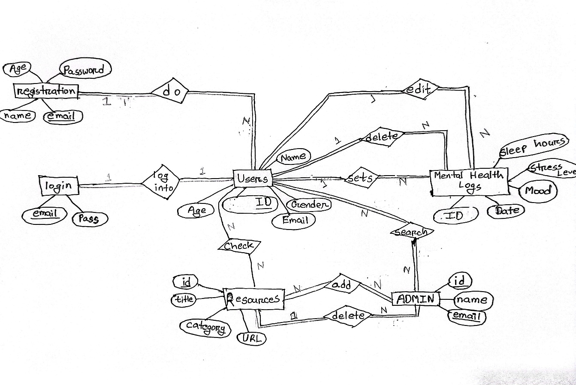

**Normalization Process:**

The system design follows the normalization principles to reduce redundancy. The database is normalized to **3rd Normal Form (3NF)**. Because it insures that:

* Already in 1NF(Each column contains only one value) and 2NF(No partial dependency)
* No data is duplicated.
* All non-key attributes depend only on the primary key.
* The design allows for efficient querying.

**The schema design:**

Mental health logs:



Resources:



Admin:



Users:



**5. Database Schema**

The database schema is derived from the ERD and consists of the following tables:

**Users Table:**

CREATE TABLE users (

user_id INT PRIMARY KEY AUTO_INCREMENT,

name VARCHAR(100),

email VARCHAR(100) UNIQUE,

password VARCHAR(255),

age INT,

gender VARCHAR(10)

);

**Mental Health Logs Table:**

CREATE TABLE mental_health_logs (

log_id INT PRIMARY KEY AUTO_INCREMENT,

user_id INT,

date DATE,

mood INT,

stress_level INT,

sleep_hours INT,

FOREIGN KEY (user_id) REFERENCES users(user_id)

);

**Resources Table:**

CREATE TABLE resources (

resource_id INT PRIMARY KEY AUTO_INCREMENT,

title VARCHAR(100),

category ENUM('picture', 'video', 'url'),

link VARCHAR(255)

);

**Goals Table:**

CREATE TABLE goals (

goal_id INT PRIMARY KEY AUTO_INCREMENT,

user_id INT,

goal_description TEXT,

start_date DATE,

target_date DATE,

FOREIGN KEY (user_id) REFERENCES users(user_id)

);

**Database schema Picture:**

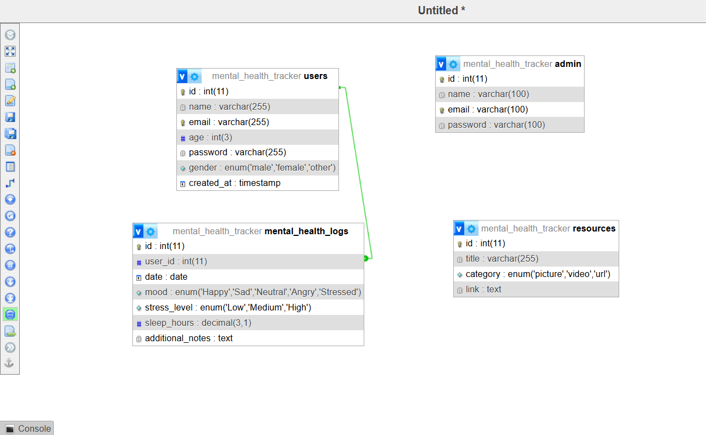

**Justification for Schema Design:**

* The schema follows 3NF to ensure minimal data redundancy and optimal data integrity.
* Foreign key constraints maintain referential integrity between the users table and related tables (mental_health_logs and goals).

**6. Performance Optimization**

To optimize database performance:

* **Indexes**: Indexes are created on frequently queried fields such as user_id, email and date in the logs.
* **Query Optimization**: SQL queries are optimized for performance using JOIN operations to reduce the number of queries to the database.
* **Normalization**: The schema is normalized to 3NF to avoid unnecessary data duplication, ensuring the database performs well even as the number of users and logs increases.

**Indexing Example:**

CREATE INDEX idx_user_id ON mental_health_logs(user_id);

**7. System Interface**

**User Registration:**

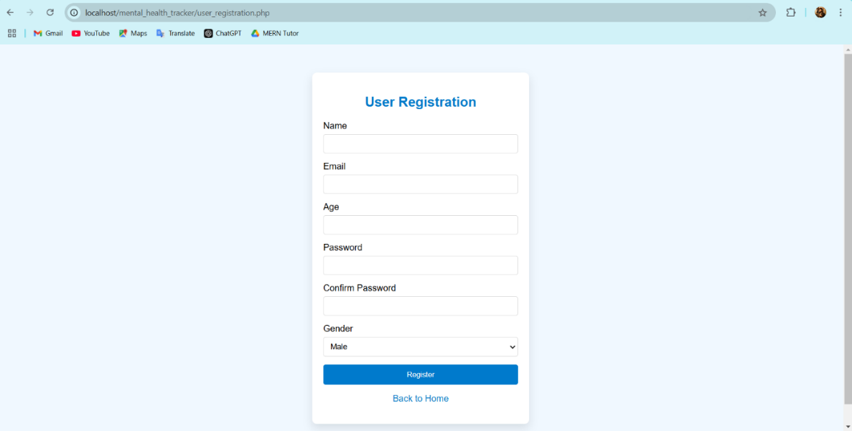

**User Dashboard:**

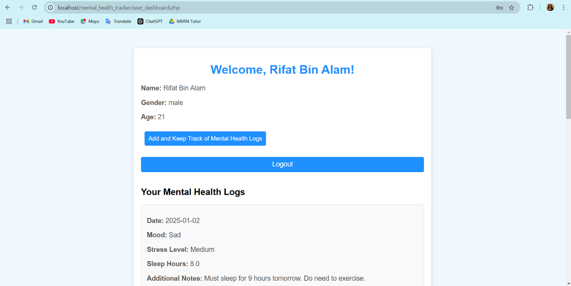

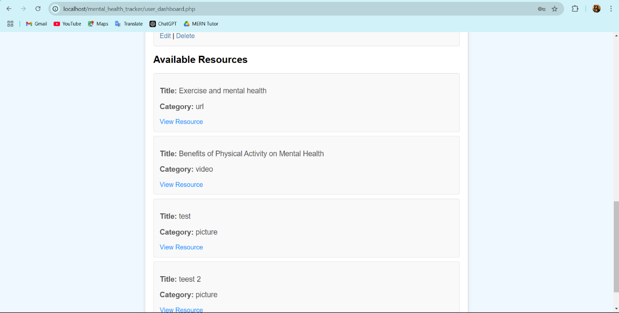

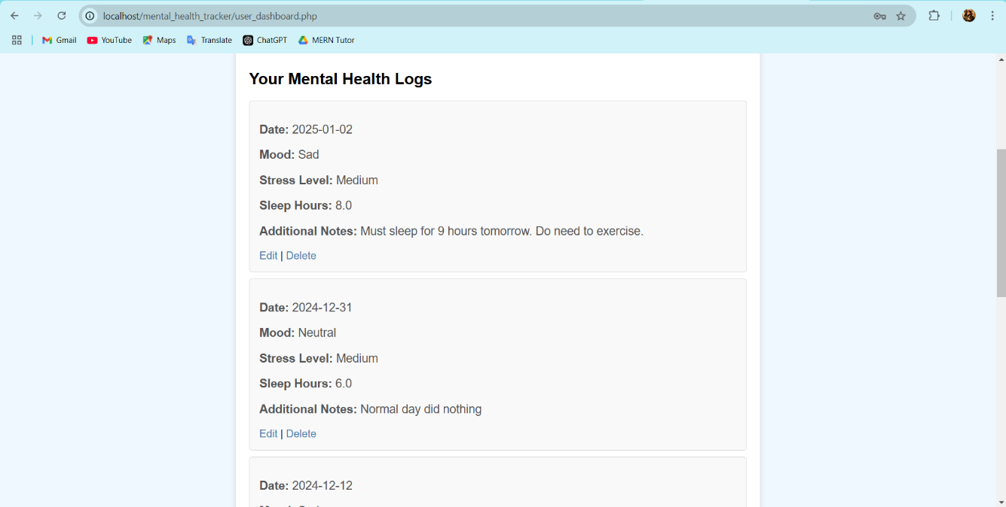

**Admin Dashboard:**

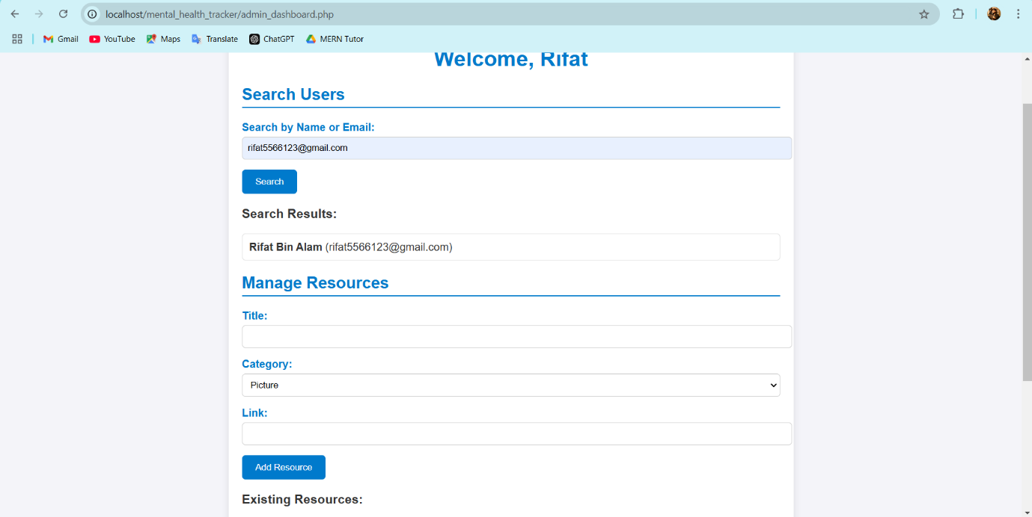

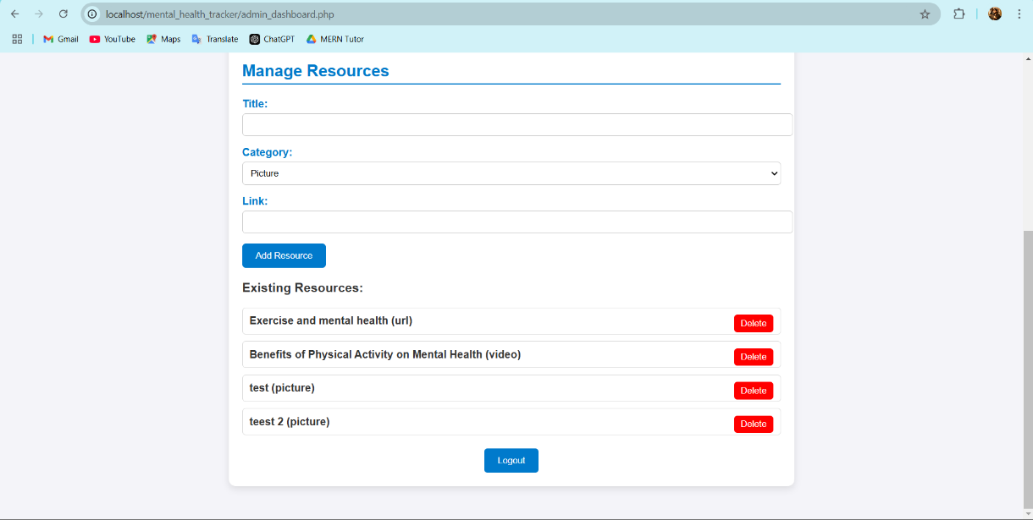

**8. Sample Queries**

**1. Fetch user logs:**

SELECT * FROM mental_health_logs WHERE user_id = 1;

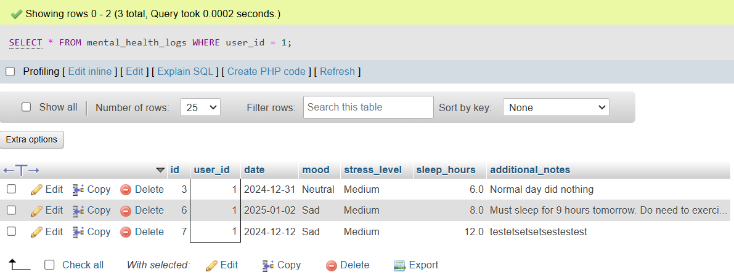

**2. Fetch all resources:**

SELECT * FROM resources;

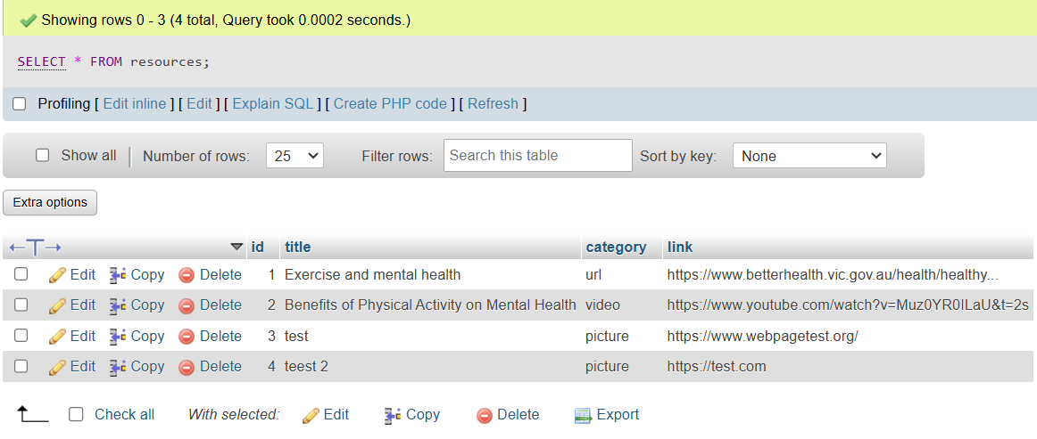

**3. Count the number of users:**

SELECT COUNT(*) FROM users;

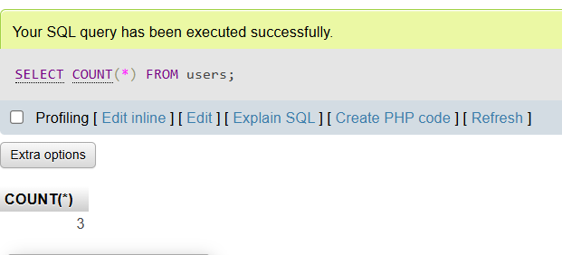

**9. Limitations and Future Work**

**Limitations:**

* The system currently lacks advanced security features like password hashing and encryption.
* There are no advanced reporting features available for users or admins to analyze mental health trends over time.

**Future Work:**

* Implement password hashing and user authentication features.
* Add a recommendation engine that suggests resources or goals based on user behavior.
* Integrate the system with external APIs for real-time data analysis.

**10. Conclusion**

The **Mental Health Tracker** is a well-structured system that allows users to track their mental health while maintaining few database design. The database schema is optimized for performance and ensures the integrity of the data. The project highlights the importance of proper database design in this system, especially those handling sensitive user data.

**11. References**

* **MySQL Documentation** – <https://dev.mysql.com/doc/>
* **Normalization Techniques** – <https://www.studytonight.com/dbms/database-normalization>
* **W3Schools** – <https://www.w3schools.com/php/php_mysql_connect.asp>